

STUDENT: NAME KELVIN MEIN
REG NO: BSCCS/2024/56078
PROJECT TITLE: SECURE FILE ENCRYPTION SYSTEM
SELECTED TECHNOLOGIES:
- Python+SQLite
- OpenSSL
- Kali linux security tools
GitHub link:
https://github.com/KelvinMein/Secure-File-Encryption-System

WEEK-6 SYMMETRIC CIPHERS II 3
Fig 1: S-Box demonstration 3
Fig 2 : Permutation Demonstration 4
Fig 3 :SPN Encryption 5
Fig 4 : Avalanche Effect Test 6
Fig 5 : SPN Decryption 7
WEEK-6 REFLECTION 7
WEEK-7 CRYPTOANALYSIS OF BLOCK CIPHERS 8
Fig 1 : Plaintext-Ciphertext pairs 8
Fig 2 : XOR Key Recovery 9
Fig 3 : Frequency Analysis 10
Fig 4 : Simple Differential Analysis 11
Fig 5 : Cryptoanalysis Summary 12
WEEK-7 REFLECTION 12

WEEK-6 SYMMETRIC CIPHERS II

Fig 1: S-Box demonstration
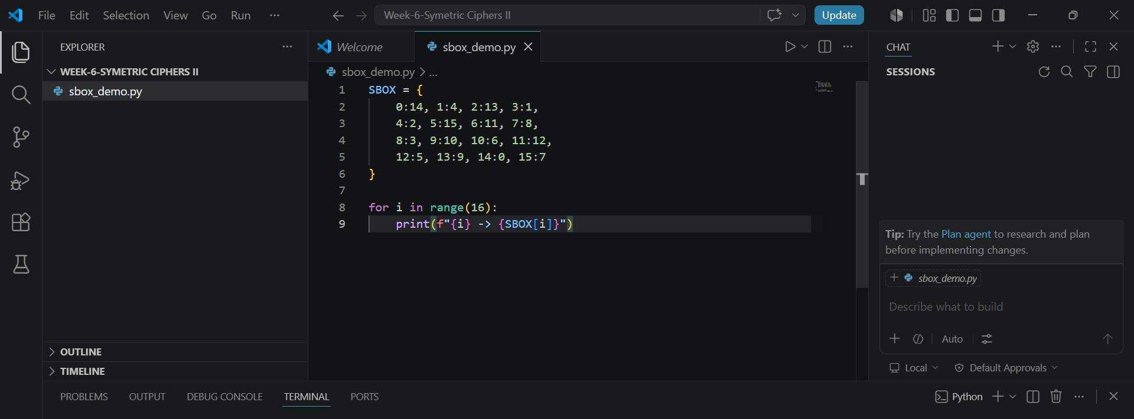
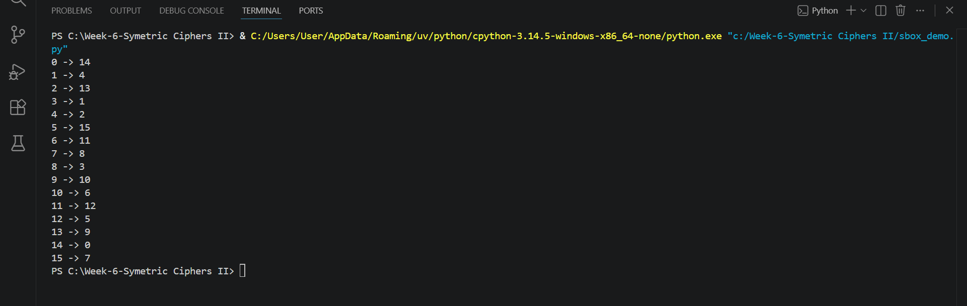

Fig 2 : Permutation Demonstration
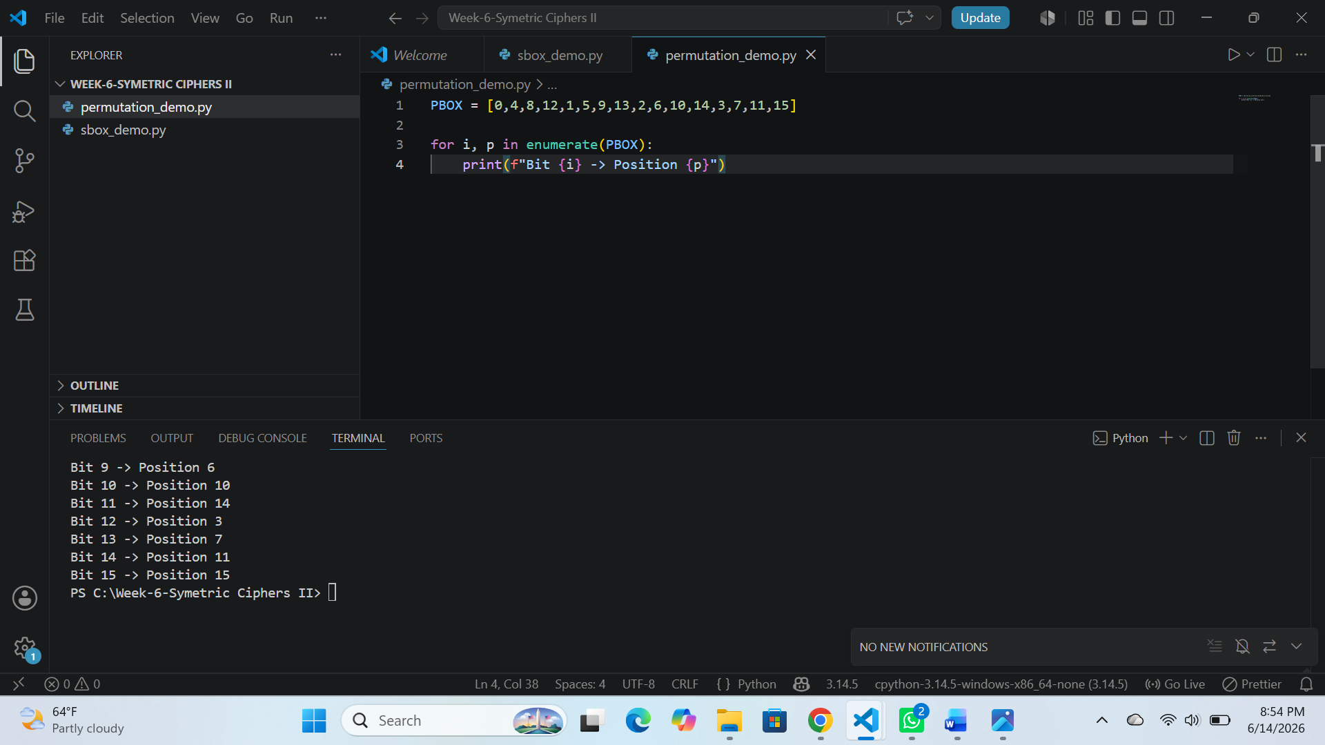

Fig 3 :SPN Encryption
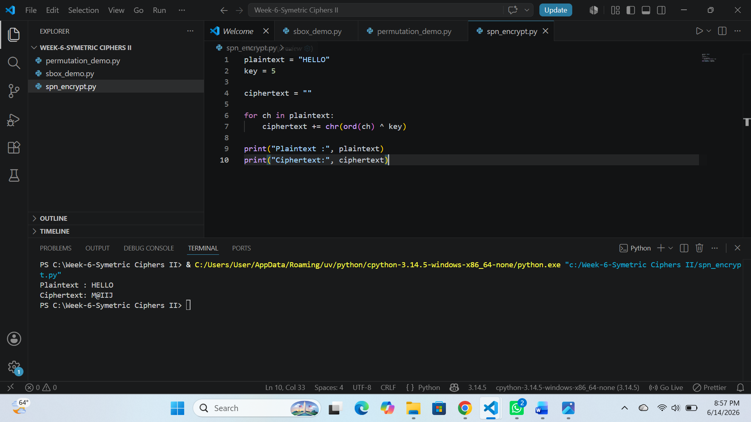

Fig 4 : Avalanche Effect Test
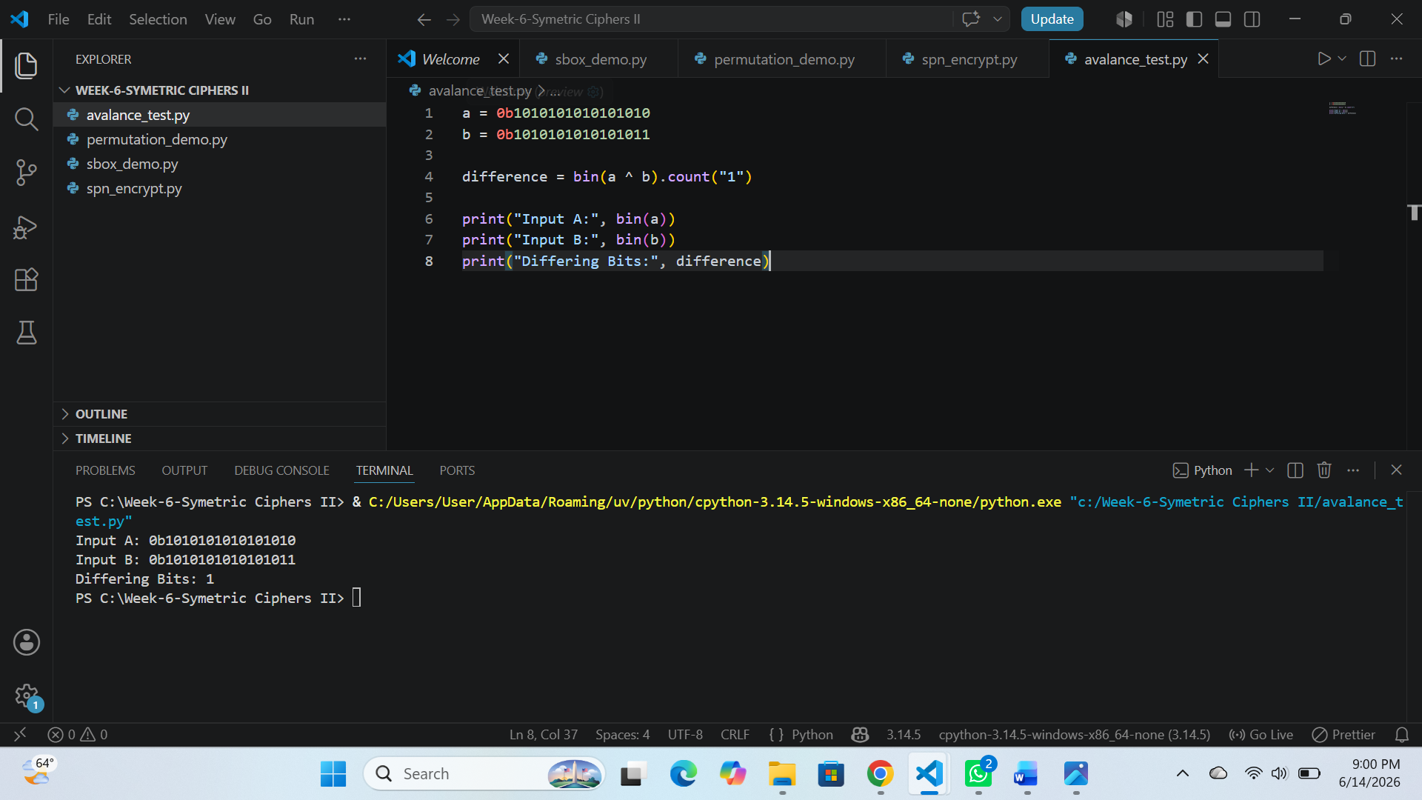

Fig 5 : SPN Decryption
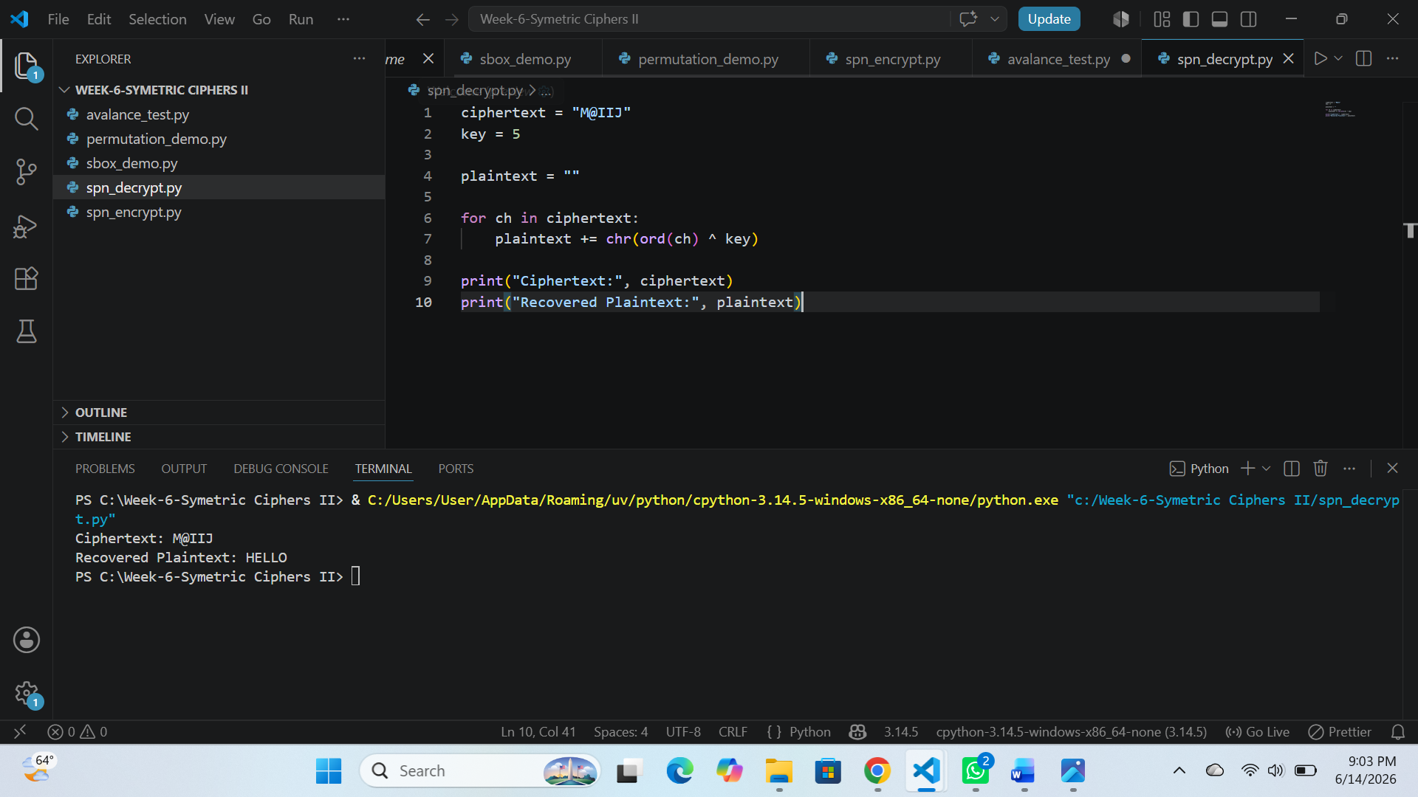

WEEK-6 REFLECTION
The implementation of a Substitution-Permutation Network enhanced my understanding of block cipher design. Through S-box substitution, permutation layers, and avalanche effect testing, I observed how confusion and diffusion improve security. The practical exercises demonstrated the importance of non-linearity in protecting encrypted data.

WEEK-7 CRYPTOANALYSIS OF BLOCK CIPHERS

Fig 1 : Plaintext-Ciphertext pairs
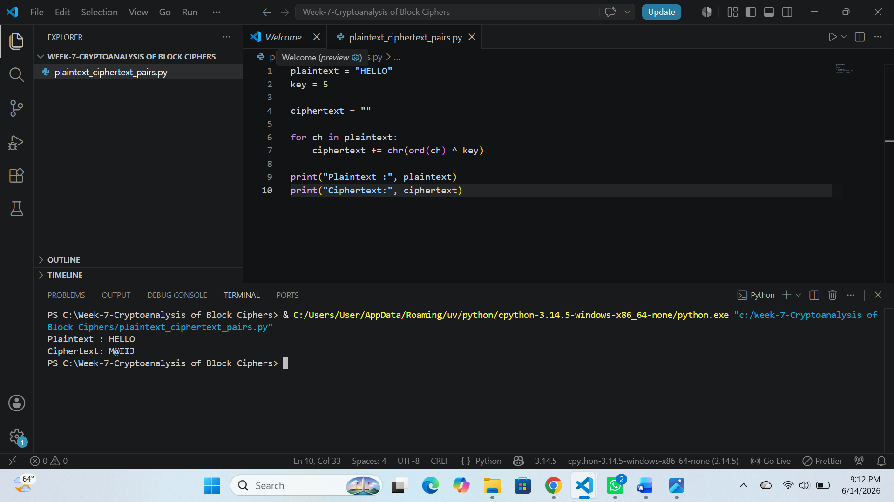

Fig 2 : XOR Key Recovery
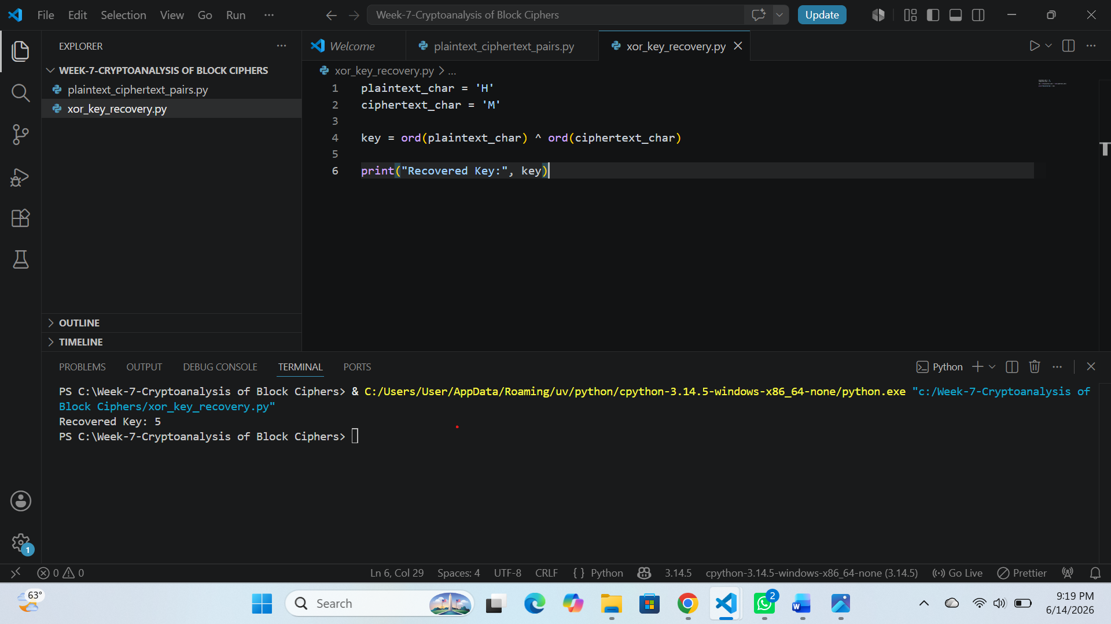

Fig 3 : Frequency Analysis
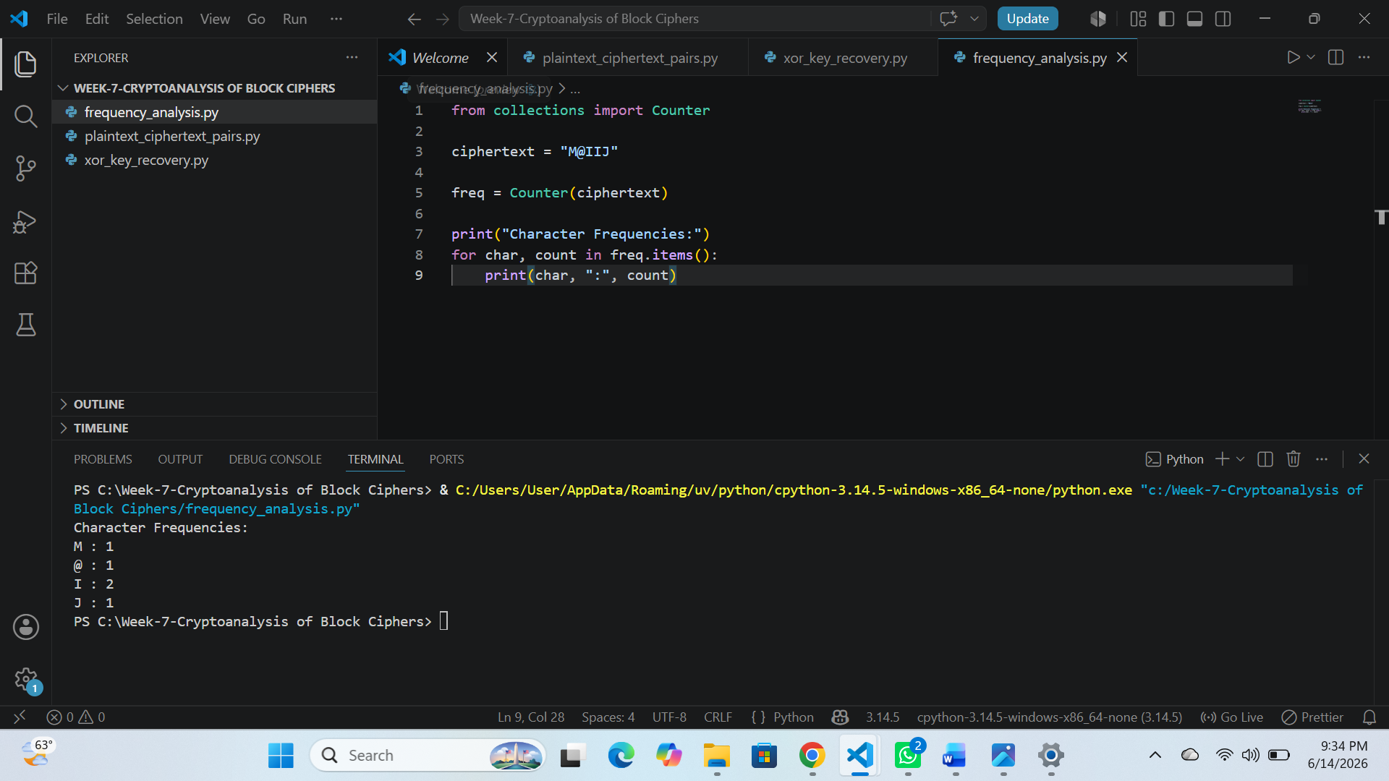

Fig 4 : Simple Differential Analysis
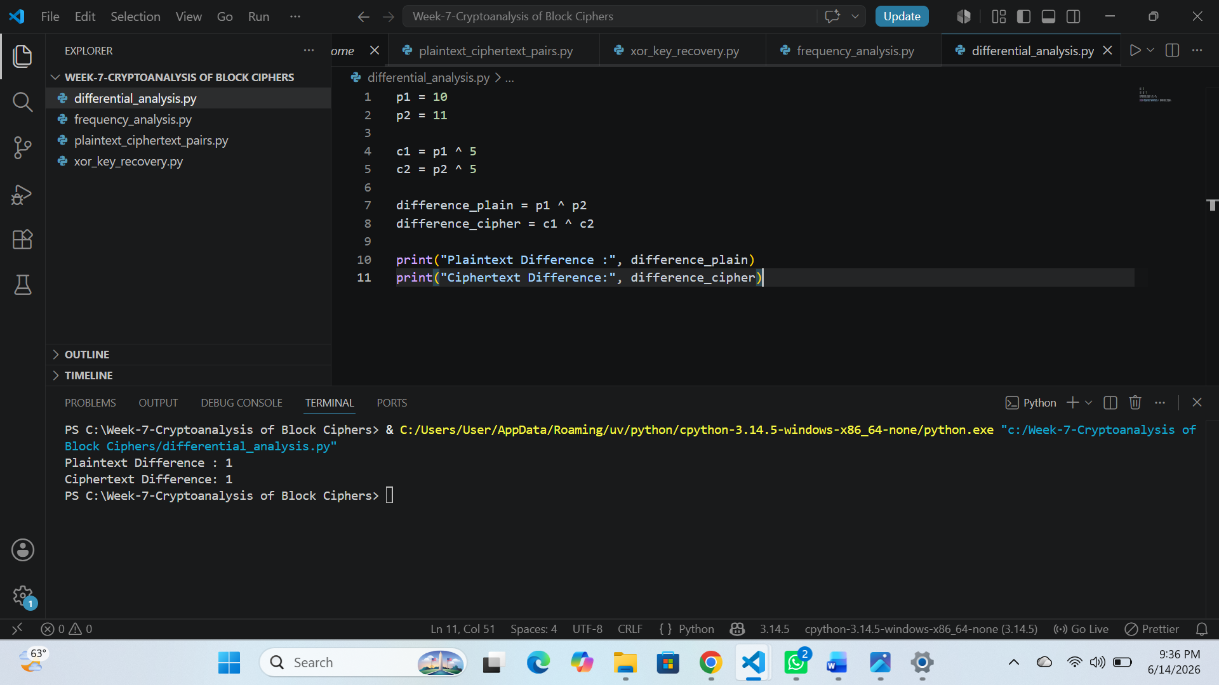

Fig 5 : Cryptoanalysis Summary
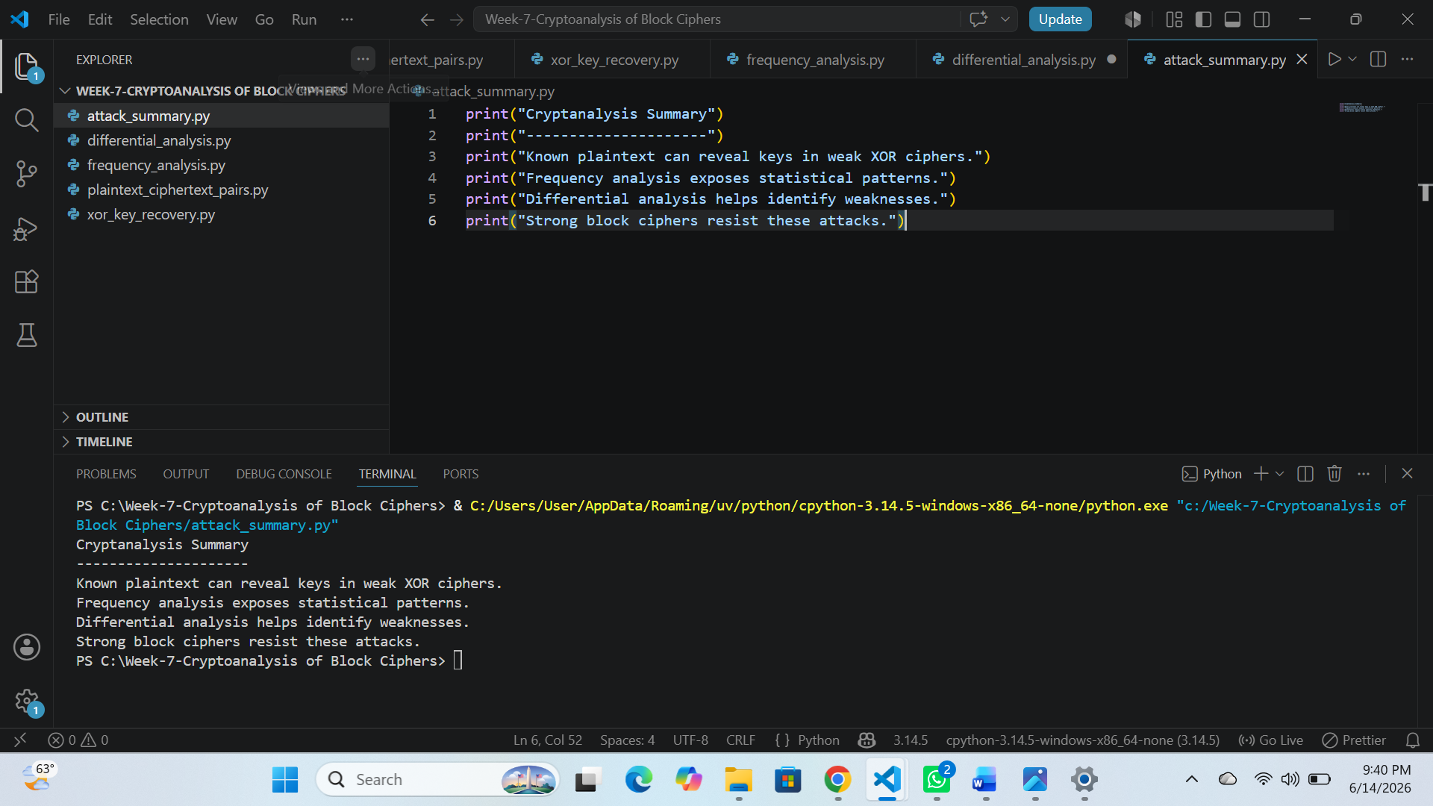

WEEK-7 REFLECTION
The cryptanalysis activities provided insight into how attackers analyze encrypted information. By performing known plaintext, frequency, and differential analysis, I learned how weaknesses in cipher design can be exploited. The exercises emphasized the need for robust encryption algorithms that can withstand analytical attacks.

